Introduction to DBMS

1. Introduction to SQL
Lab 1: Create a new database named school_db and a table called students with the
following columns: student_id, student_name, age, class, and address.
Answer:
Query 1: Create Database
CREATE DATABASE school_db;
Query 2: Use Database
USE school_db;
Query 3: Create Table students
CREATE TABLE students (
student_id INT PRIMARY KEY,
student_name VARCHAR(50),
age INT,
class VARCHAR(20),
address VARCHAR(100)
);
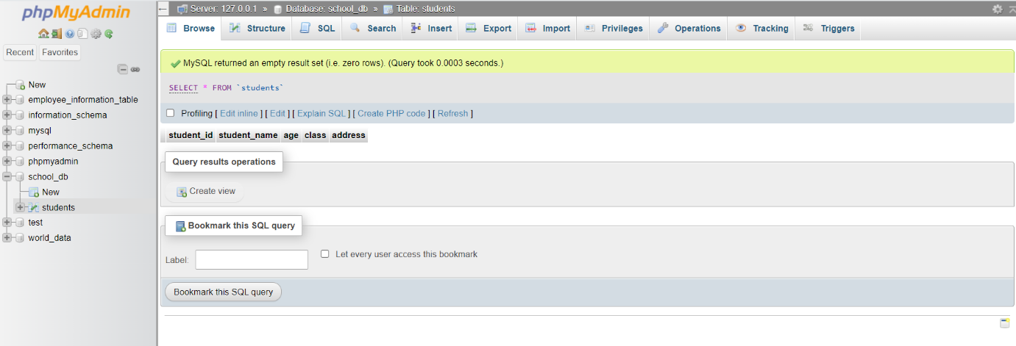

Lab 2: Insert five records into the students table and retrieve all records using the SELECT
statement.
Answer:
Query 1: Insert 5 Records
INSERT INTO students (student_id, student_name, age, class, address) VALUES
(1, 'Rahul Sharma', 12, '6A', 'Ahmedabad'),
(2, 'Priya Patel', 13, '7B', 'Surat'),
(3, 'Amit Shah', 11, '5C', 'Vadodara'),
(4, 'Neha Mehta', 14, '8A', 'Rajkot'),
(5, 'Karan Joshi', 12, '6B', 'Bhavnagar');

Query 2: Retrieve All Records
SELECT * FROM students;
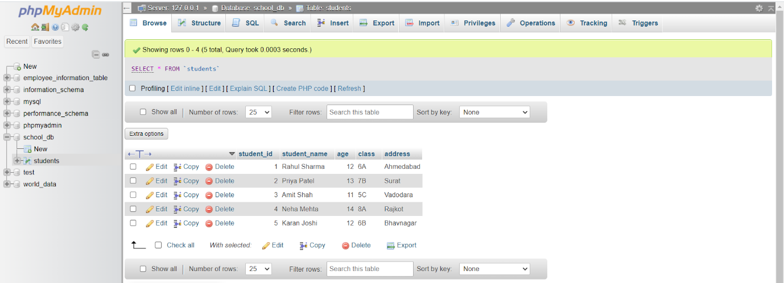

2. SQL Syntax
Lab 1: Write SQL queries to retrieve specific columns (student_name and age) from the
students table.
Answer:
Query: Retrieve Specific Columns (student_name and age)
SELECT student_name, age FROM students;
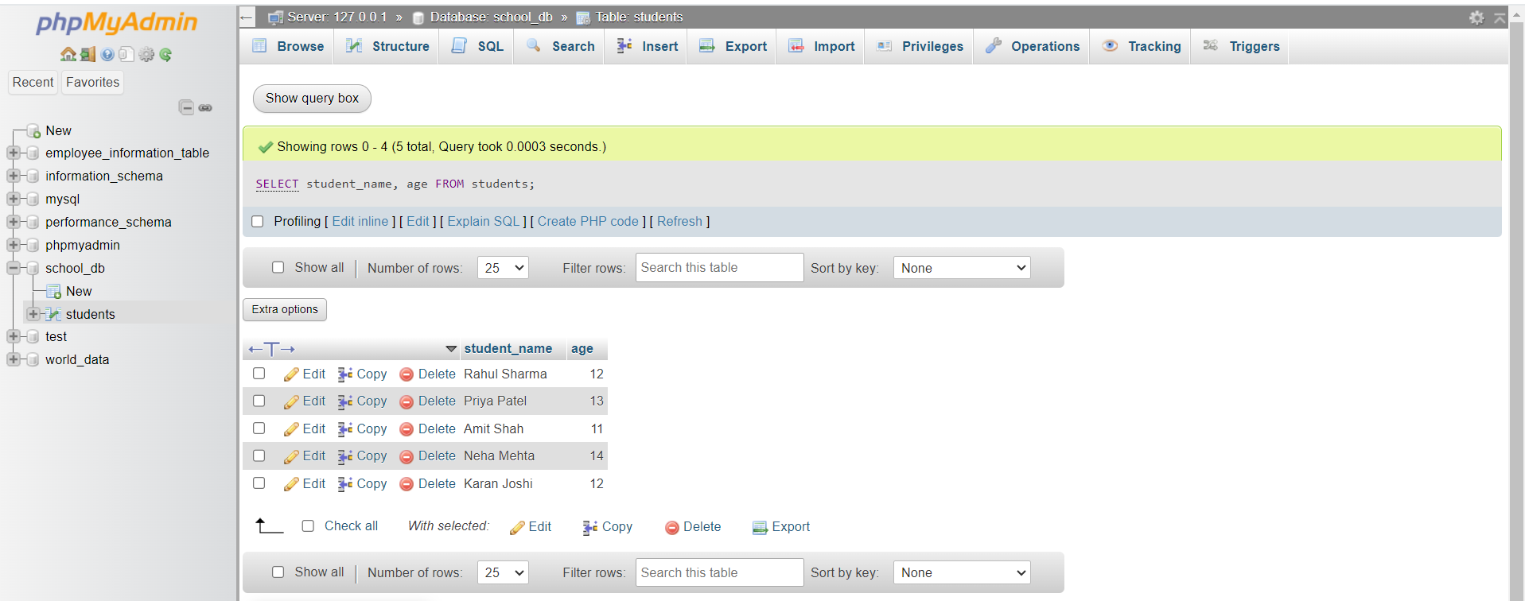

Lab 2: Write SQL queries to retrieve all students whose age is greater than 10.
Answer:
Query: Retrieve All Students Whose Age > 10
SELECT * FROM students WHERE age > 10;
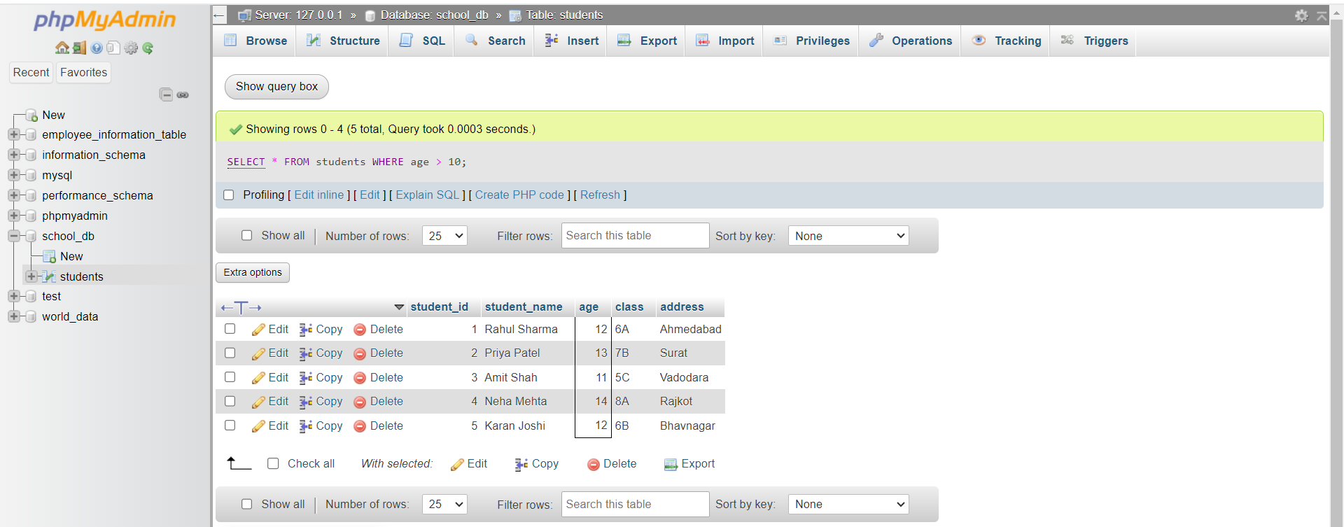

3. SQL Constraints
Lab 1: Create a table teachers with the following columns: teacher_id (Primary Key),
teacher_name (NOT NULL), subject (NOT NULL), and email (UNIQUE).
Answer:
Query: Create teachers Table
CREATE TABLE teachers (
teacher_id INT PRIMARY KEY,
teacher_name VARCHAR(50) NOT NULL,
subject VARCHAR(50) NOT NULL,
email VARCHAR(100) UNIQUE
);
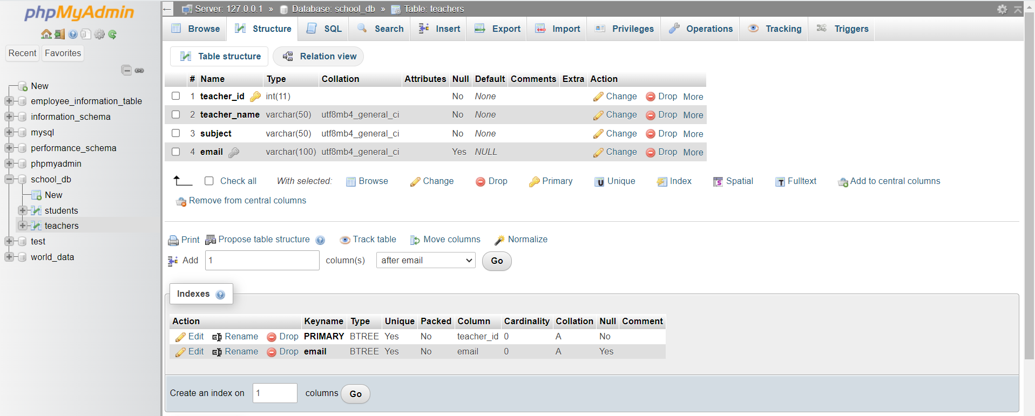

Lab 2: Implement a FOREIGN KEY constraint to relate the teacher_id from the
teachers table with the students table.
Answer:
Query 1: Add teacher_id column to students table
ALTER TABLE students ADD teacher_id INT;
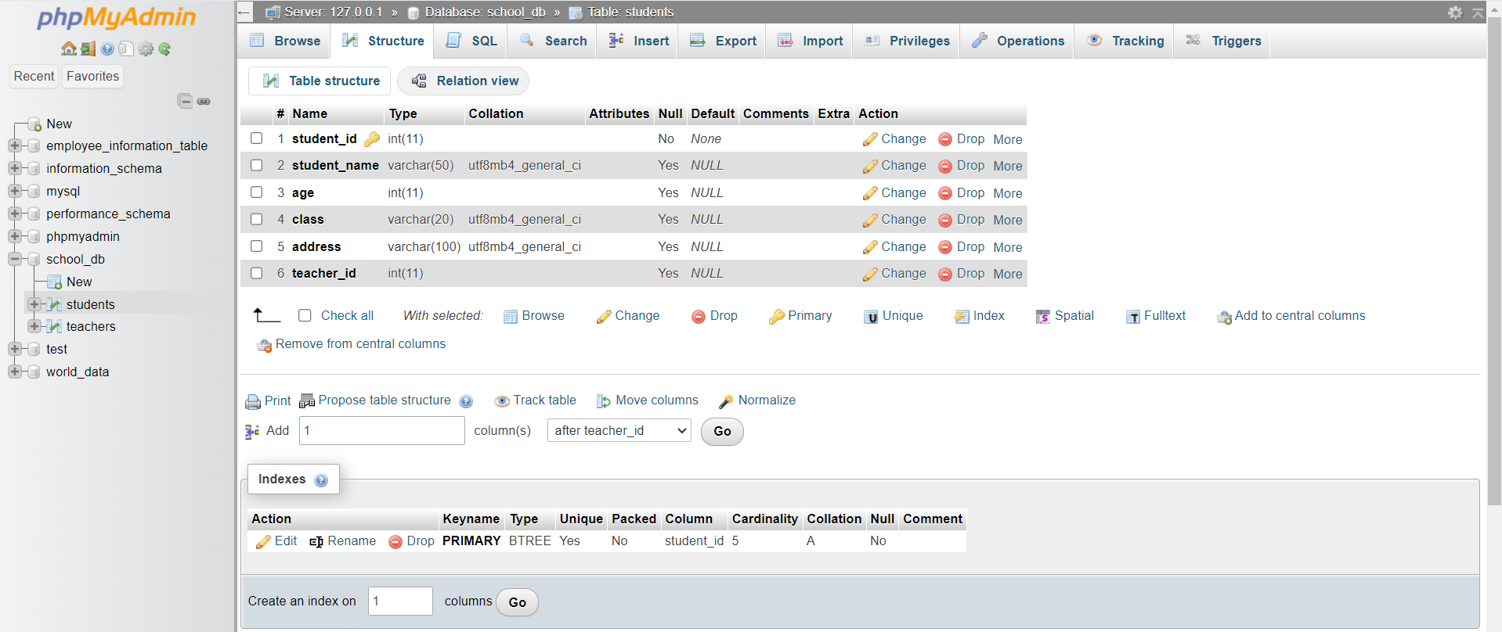

Query 2: Add FOREIGN KEY Constraint
ALTER TABLE students
ADD CONSTRAINT fk_teacher
FOREIGN KEY (teacher_id)
REFERENCES teachers(teacher_id);
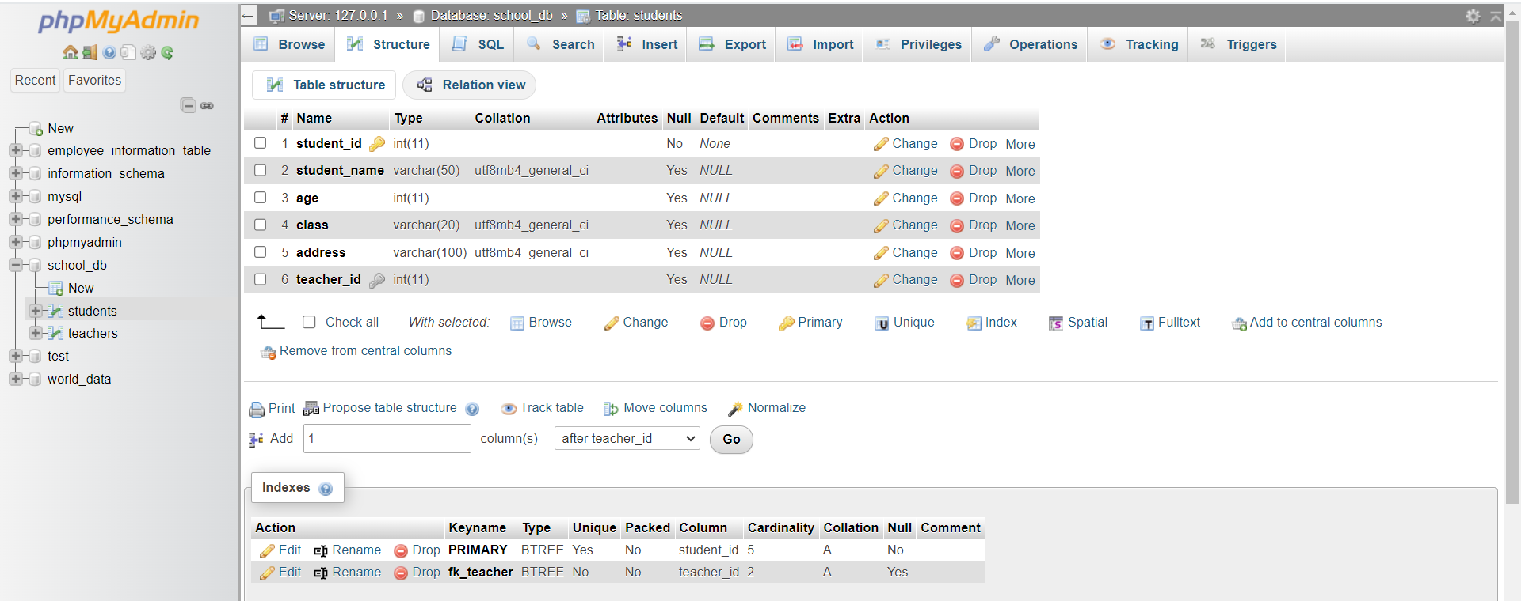

4. Main SQL Commands and Sub-commands (DDL)
Lab 1: Create a table courses with columns: course_id, course_name, and
course_credits. Set the course_id as the primary key.
Answer:
Query: Create a table courses
CREATE TABLE courses (
course_id INT PRIMARY KEY,
course_name VARCHAR(100),
course_credits INT
);
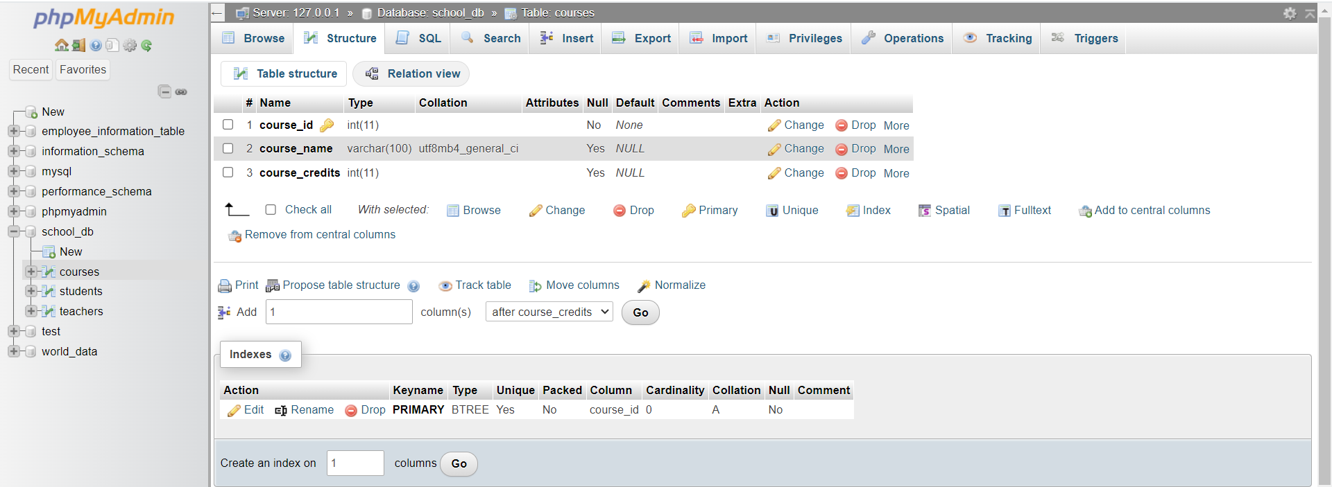

Lab 2: Use the CREATE command to create a database university_db.
Answer:
Query: Create a Database university_db
CREATE DATABASE university_db;
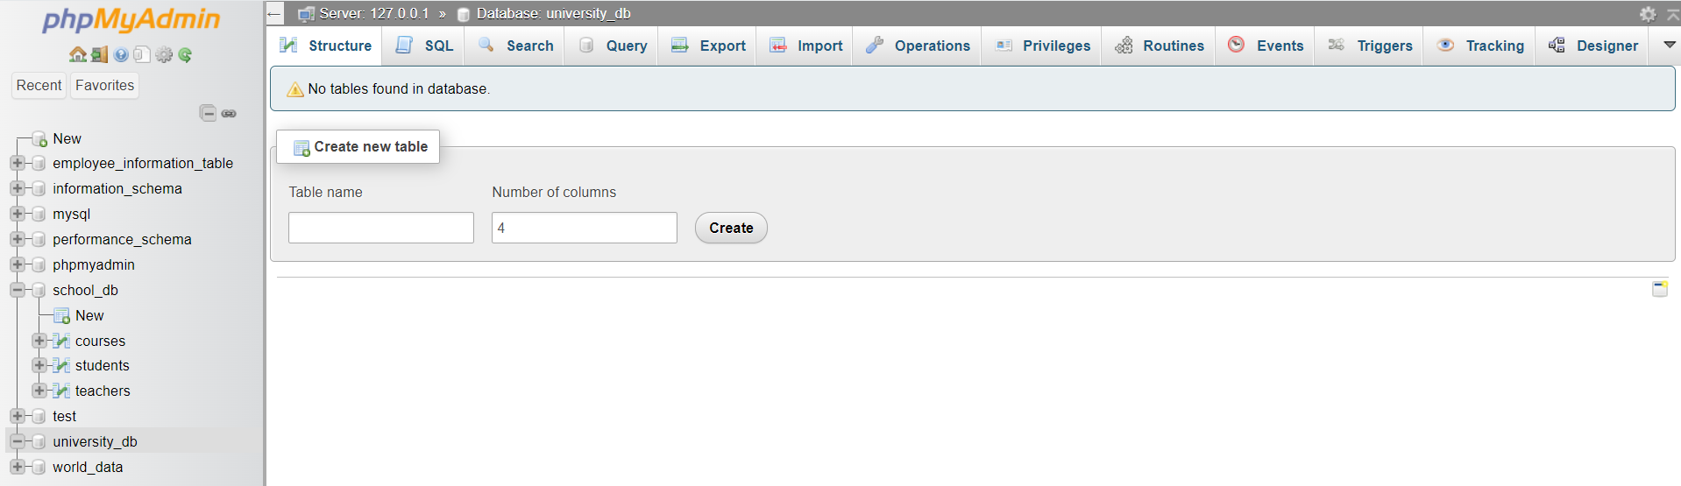

5. ALTER Command
Lab 1: Modify the courses table by adding a column course_duration using the ALTER
command.
Answer:
Query: Add a New Column (course_duration) to courses Table
ALTER TABLE courses ADD course_duration VARCHAR(50);
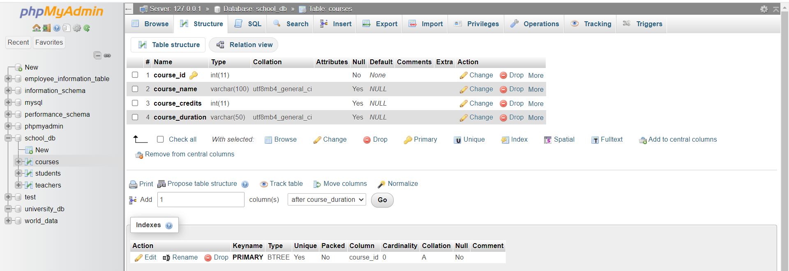

Lab 2: Drop the course_credits column from the courses table.
Answer:
Query: Drop the Column (course_credits) from courses Table
ALTER TABLE courses DROP COLUMN course_credits;
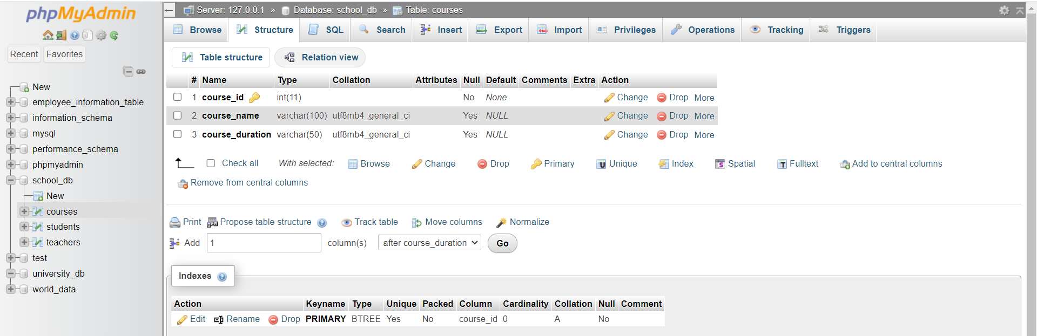

6. DROP Command
Lab 1: Drop the teachers table from the school_db database.
Answer:
Query: Drop the teachers table
DROP TABLE teachers;
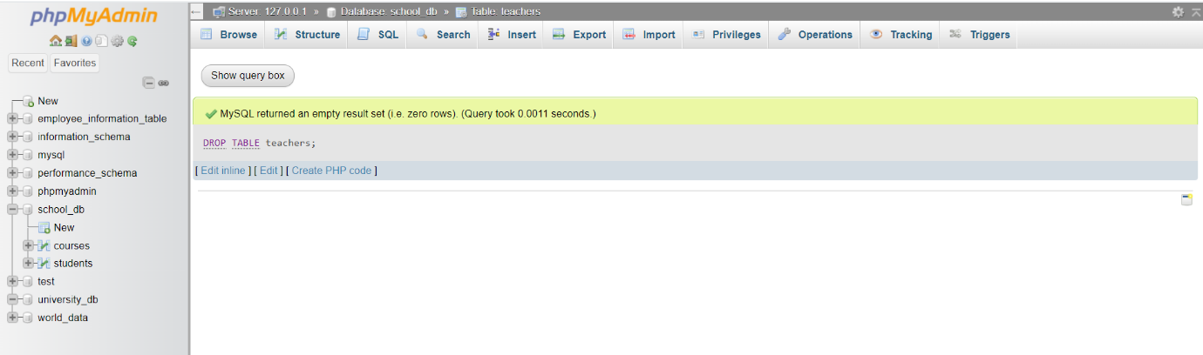

Lab 2: Drop the students table from the school_db database and verify that the table has
been removed.
Answer:
Query 1: Drop the students table and verify removal
DROP TABLE students;
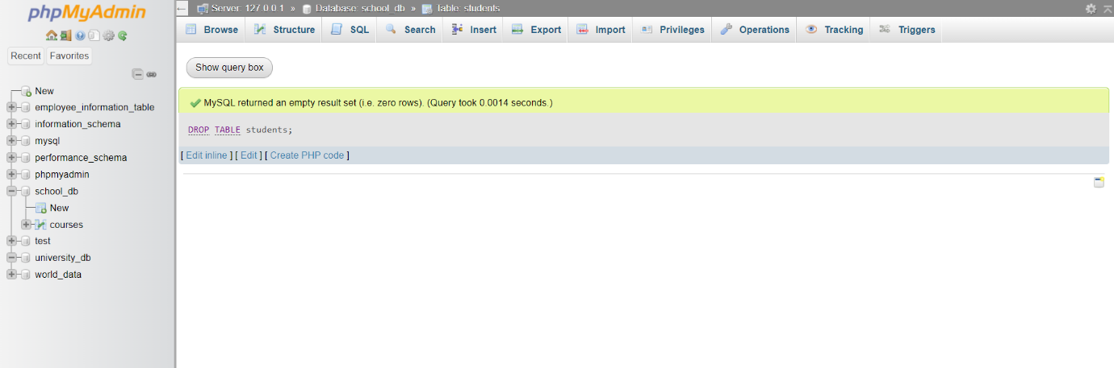

Query 2: Verify that the table is removed
SHOW TABLES;
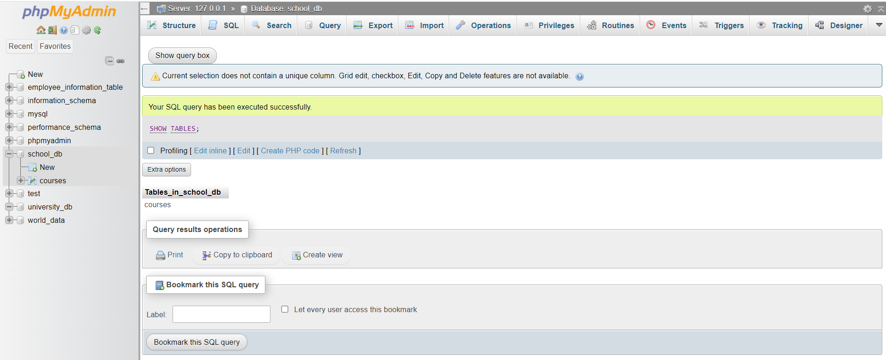

7. Data Manipulation Language (DML)
Lab 1: Insert three records into the courses table using the INSERT command.
Answer:
Query: Insert 3 Records into courses Table
INSERT INTO courses (course_id, course_name, course_duration)
VALUES
(101, 'Computer Science Basics', '3 Months'),
(102, 'Database Management', '2 Months'),
(103, 'Web Development', '4 Months');
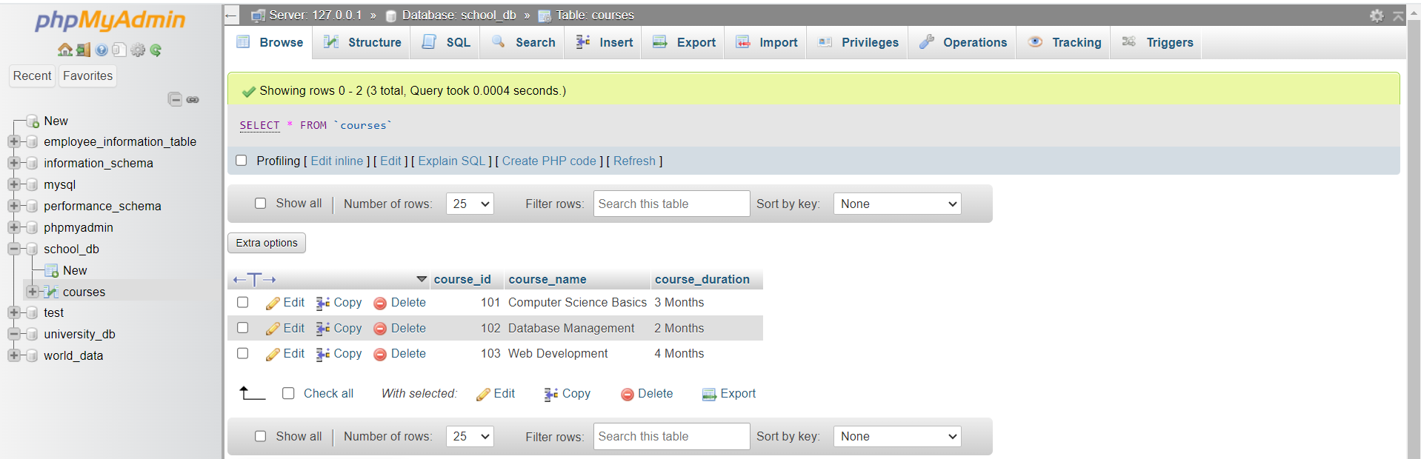

Lab 2: Update the course duration of a specific course using the UPDATE command.
Answer:
Query: Update Course Duration of a Specific Course
Example: Update duration of course_id = 102
UPDATE courses SET course_duration = '3.5 Months' WHERE course_id = 102;
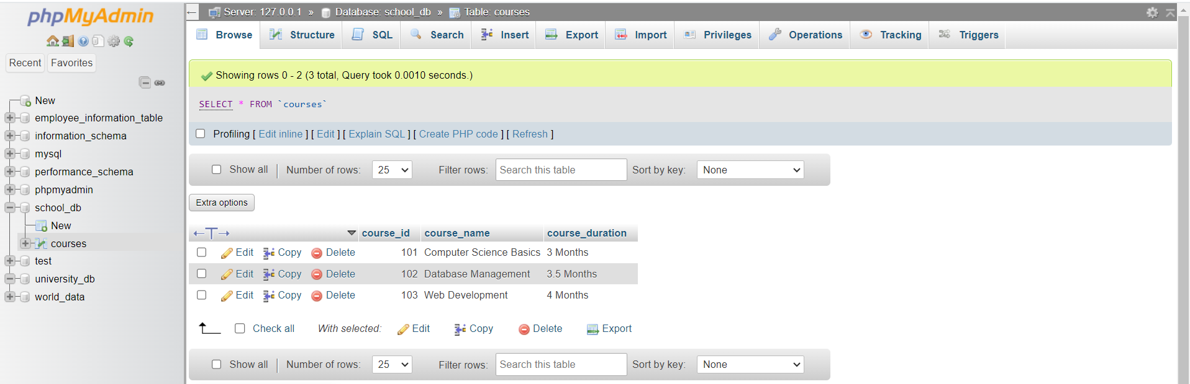

Lab 3: Delete a course with a specific course_id from the courses table using the DELETE
command.
Answer:
Query: Delete a course using DELETE Command
Example: Delete course with course_id = 103
DELETE FROM courses WHERE course_id = 103;
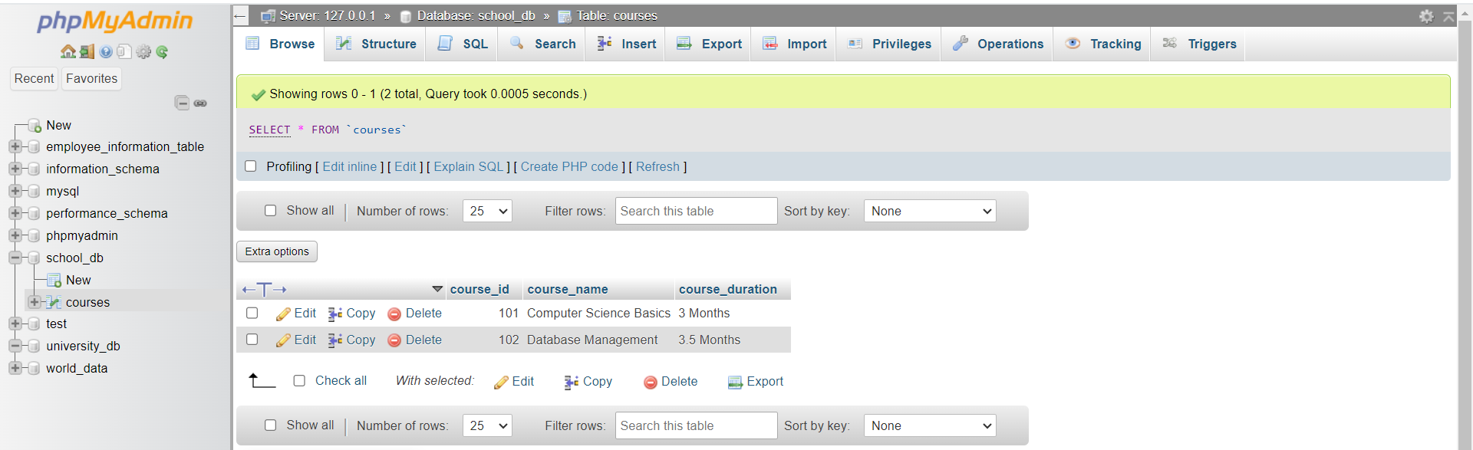

8. Data Query Language (DQL)
Lab 1: Retrieve all courses from the courses table using the SELECT statement.
Answer:
Query: Retrieve all courses
SELECT * FROM courses;
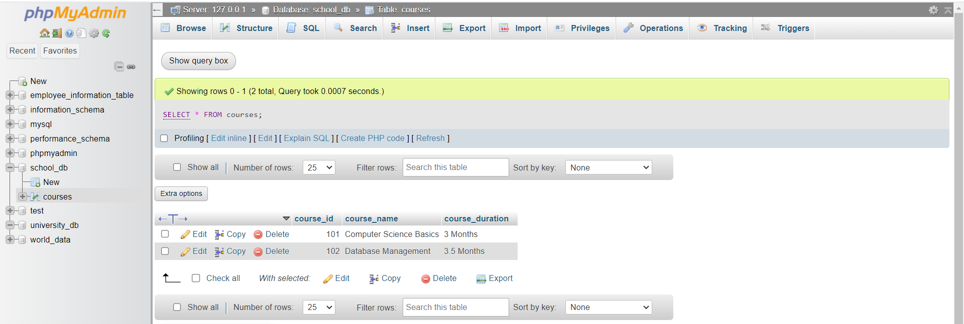

Lab 2: Sort the courses based on course_duration in descending order using ORDER BY.
Answer:
Query: Sort Courses by course_duration (Descending Order)
SELECT * FROM courses ORDER BY course_duration DESC;
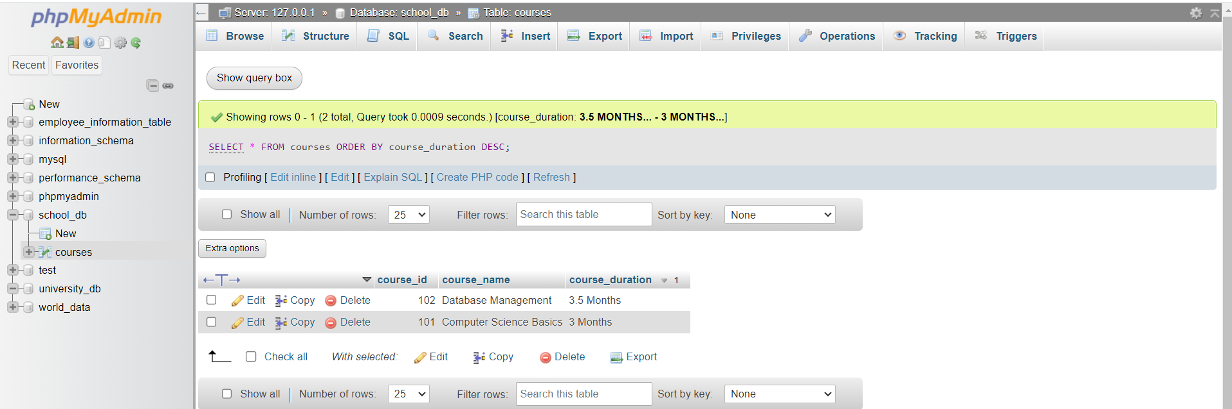

Lab 3: Limit the results of the SELECT query to show only the top two courses using LIMIT.
Answer:
Query: Show only top 2 courses using LIMIT
SELECT * FROM courses ORDER BY course_duration DESC LIMIT 2;
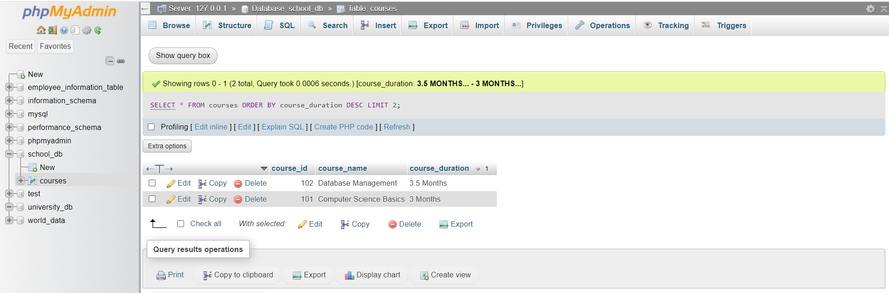

9. Data Control Language (DCL)
Lab 1: Create two new users user1 and user2 and grant user1 permission to SELECT
from the courses table.
Answer:
Query 1: Create two new users user1 and user2
Step 1: Create user1
CREATE USER 'user1'@'localhost' IDENTIFIED BY 'password1';
Step 2: Create user2
CREATE USER 'user2'@'localhost' IDENTIFIED BY 'password2';
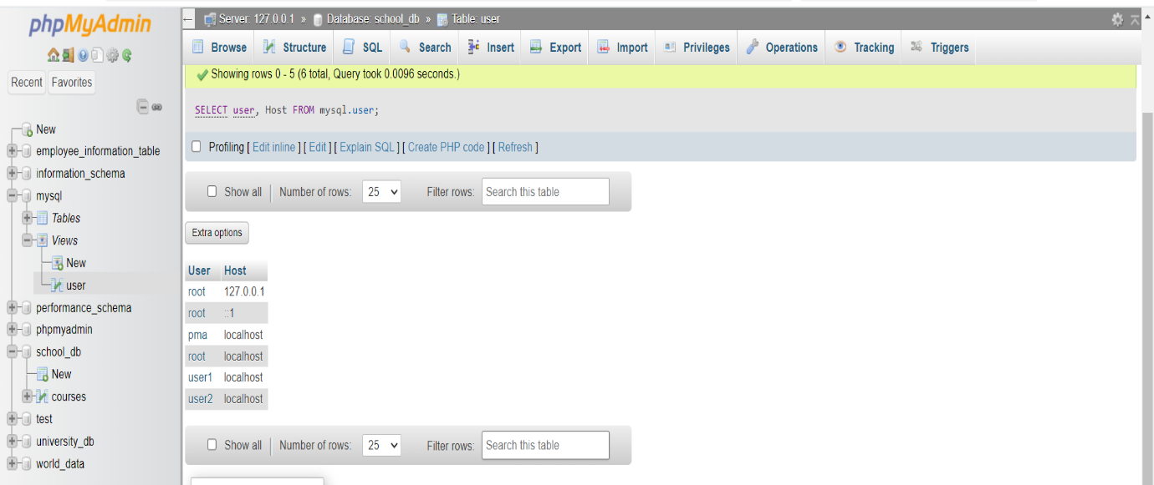

Query 2: Grant SELECT permission on courses table to user1
GRANT SELECT ON school_db.courses TO 'user1'@'localhost';
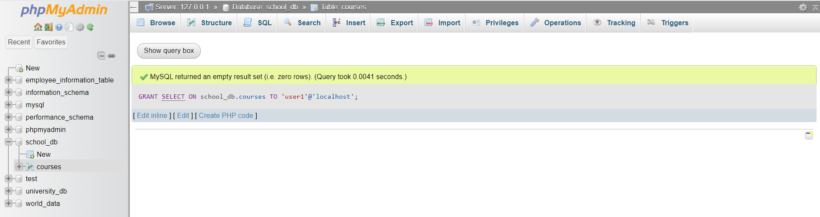

Lab 2: Revoke the INSERT permission from user1 and give it to user2.
Answer:
Query 1: Revoke INSERT permission from user1
REVOKE INSERT ON school_db.courses FROM 'user1'@'localhost';
Query 2: Grant INSERT permission to user2
GRANT INSERT ON school_db.courses TO 'user2'@'localhost';
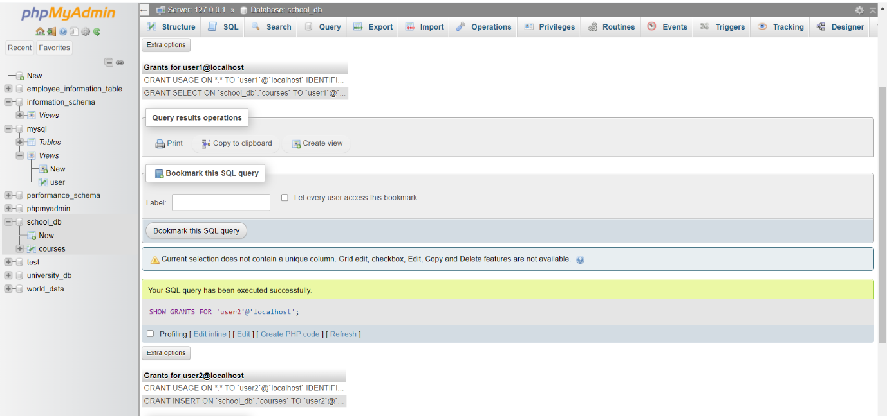

10. Transaction Control Language (TCL)
Lab 1: Insert a few rows into the courses table and use COMMIT to save the changes.
Answer:
Query: Insert a few rows + COMMIT
START TRANSACTION;

INSERT INTO courses (course_id, course_name, course_duration)
VALUES
(104, 'Cyber Security', '2 Months'),
(105, 'Data Analytics', '3 Months');

COMMIT;
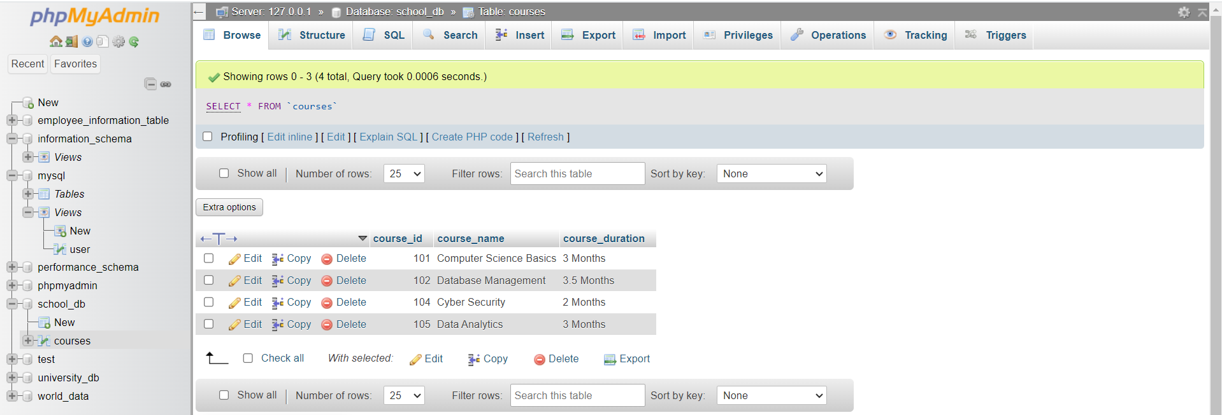
- Rows 104 and 105 will appear permanently.

Lab 2: Insert additional rows, then use ROLLBACK to undo the last insert operation.
Answer:
Query: Insert additional rows + ROLLBACK
START TRANSACTION;

INSERT INTO courses (course_id, course_name, course_duration)
VALUES (106, 'Cloud Computing', '5 Months');

ROLLBACK;
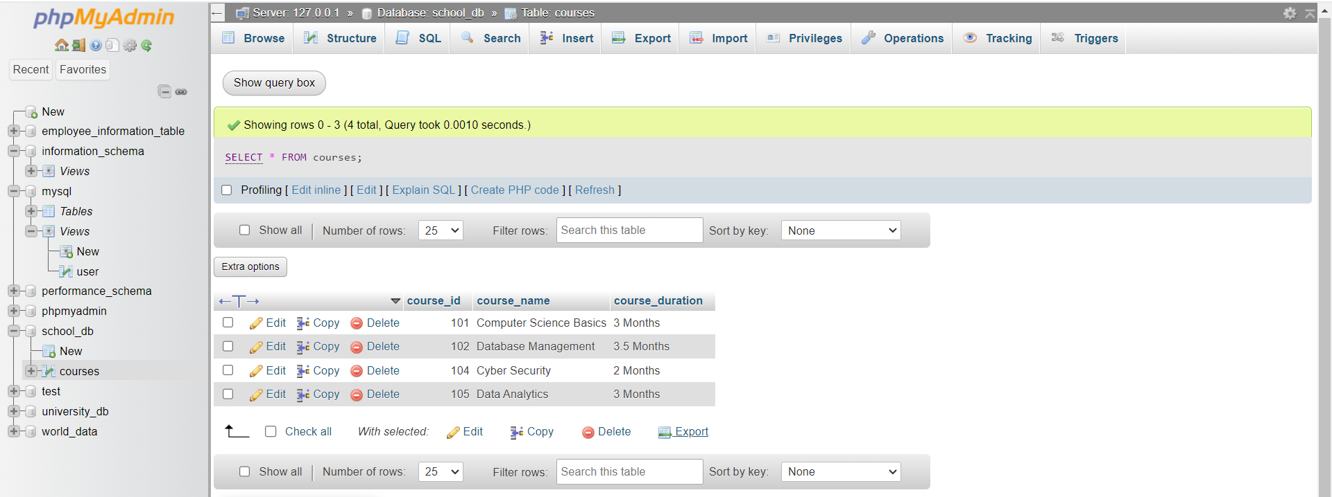
- Course_id 106 will NOT appear because rollback cancelled the insert.

Lab 3: Create a SAVEPOINT before updating the courses table, and use it to roll back
specific changes.
Answer:
Query: SAVEPOINT + ROLLBACK TO SAVEPOINT
START TRANSACTION;

-- Create savepoint
SAVEPOINT before_update;

-- Update a course
UPDATE courses SET course_duration = '6 Months' WHERE course_id = 101;

-- Rollback only this update
ROLLBACK TO before_update;

-- Commit remaining changes
COMMIT;
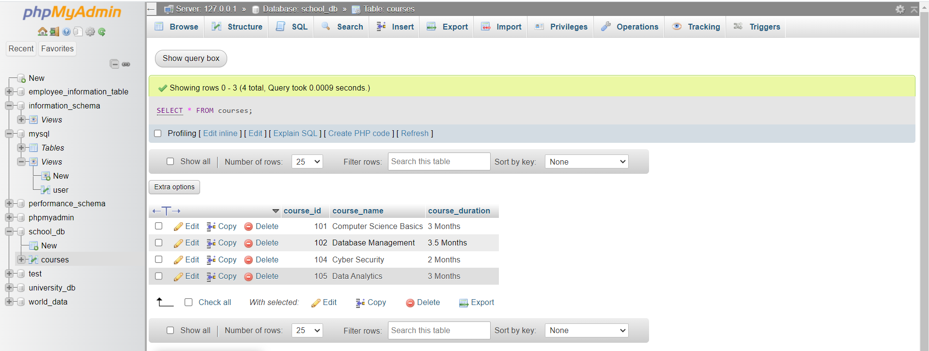
- Course_id 101 duration will remain ‘3 Months’ (rollback undo the update)

11. SQL Joins
Lab 1: Create two tables: departments and employees. Perform an INNER JOIN to
display employees along with their respective departments.
Answer:
Query 1: Create two tables
- CREATE TABLE departments (
dept_id INT PRIMARY KEY,
dept_name VARCHAR(50)
);
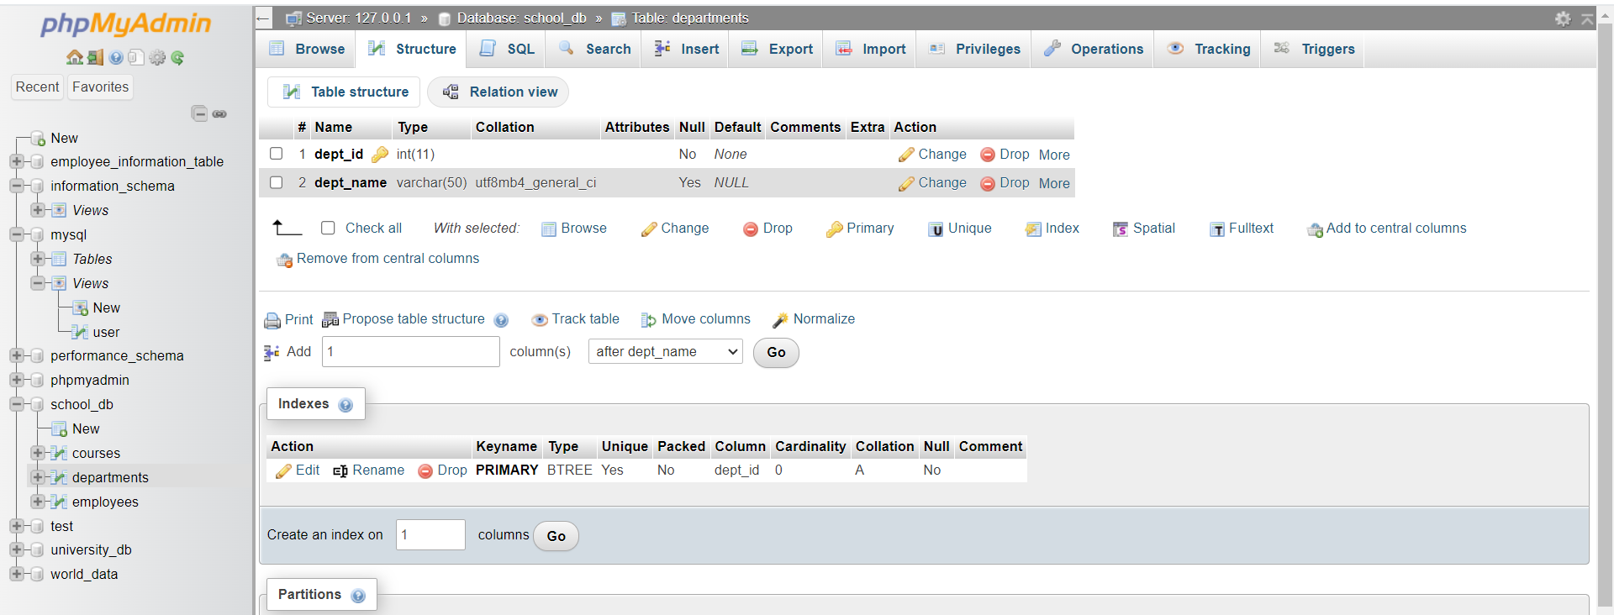
- CREATE TABLE employees (
emp_id INT PRIMARY KEY,
emp_name VARCHAR(50),
dept_id INT,
FOREIGN KEY (dept_id) REFERENCES departments(dept_id)
);
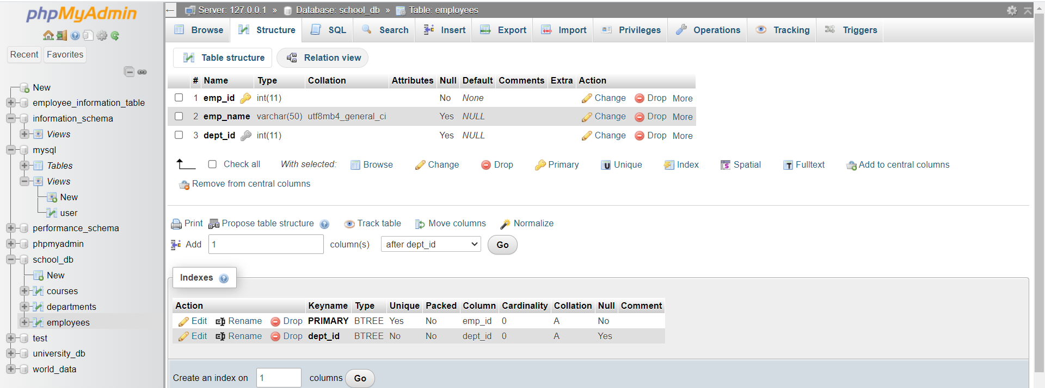
Query 2: Insert sample records
- INSERT INTO departments VALUES
(1, 'HR'),
(2, 'Finance'),
(3, 'IT');
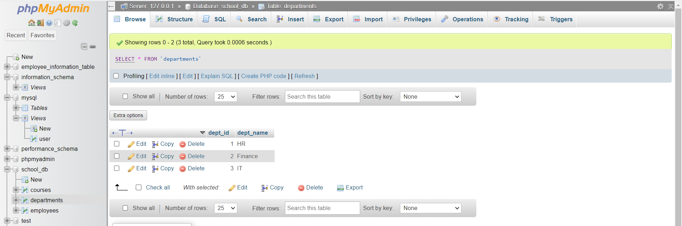

- INSERT INTO employees VALUES
(101, 'Anita', 1),
(102, 'Rahul', 2),
(103, 'Meera', 3);
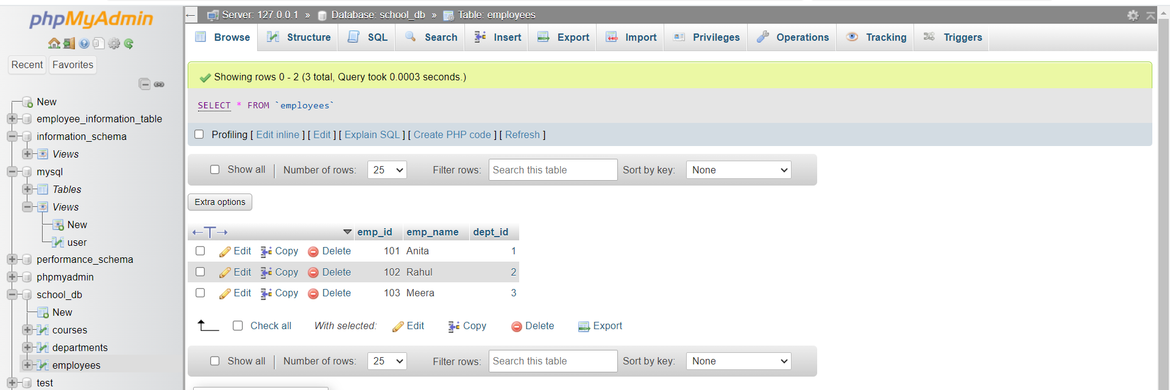

Query 3: Perform INNER JOIN
SELECT employees.emp_id, employees.emp_name, departments.dept_name
FROM employees
INNER JOIN departments ON employees.dept_id = departments.dept_id;
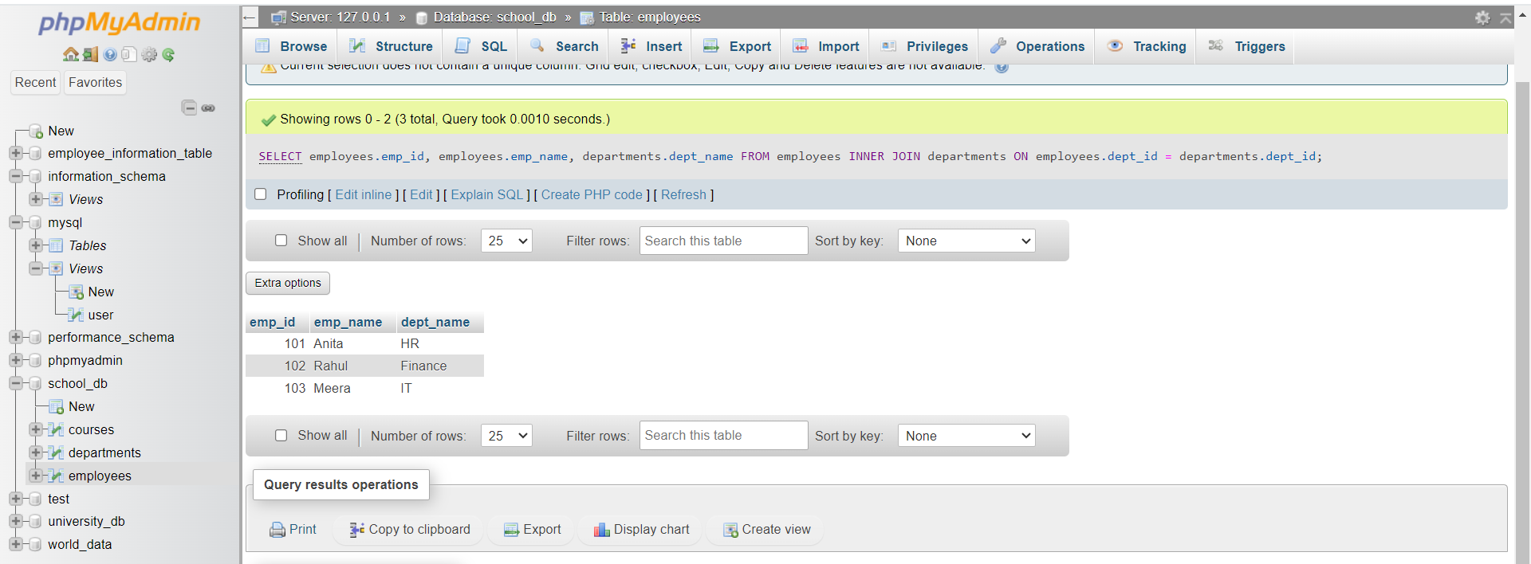
- INNER JOIN shows only matching employee – department records.

Lab 2: Use a LEFT JOIN to show all departments, even those without employees.
Answer:
Query: LEFT JOIN (Show all departments even without employees)
SELECT departments.dept_id, departments.dept_name, employees.emp_name
FROM departments
LEFT JOIN employees ON departments.dept_id = employees.dept_id;
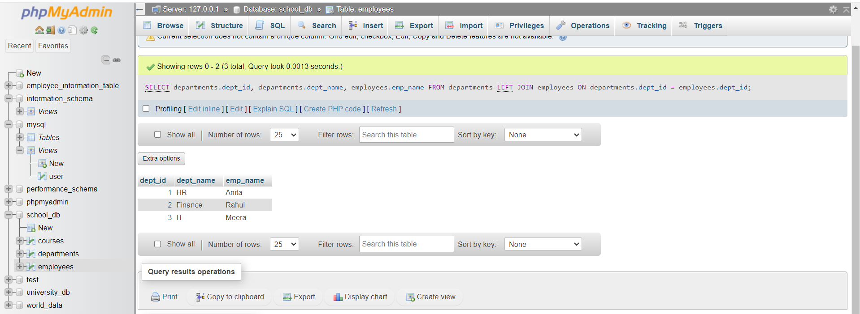

12. SQL Group By
Lab 1: Group employees by department and count the number of employees in each
department using GROUP BY.
Answer:
Query: GROUP BY – Count Employees in Each Department
SELECT dept_id, COUNT(emp_id) AS total_employees
FROM employees
GROUP BY dept_id;
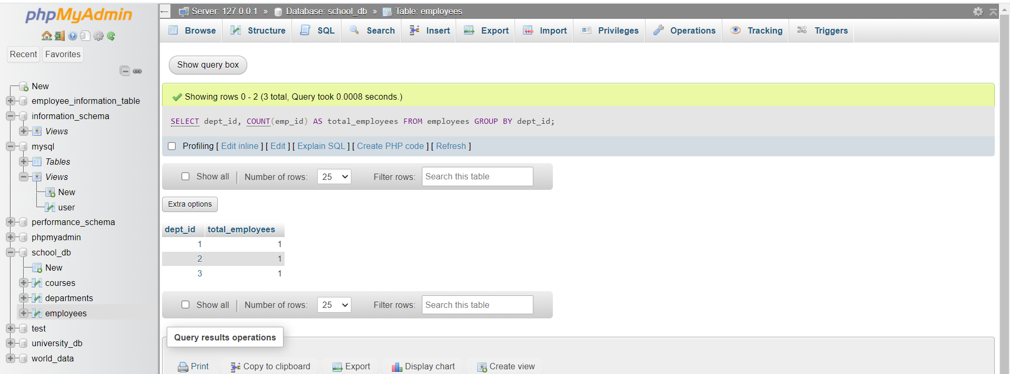

Lab 2: Use the AVG aggregate function to find the average salary of employees in each
department.
Answer:
Important note:
- To use Lab 2, your employees table must have a salary column, e.g.:
ALTER TABLE employees ADD salary INT;
- And insert/update salaries:
UPDATE employees SET salary = 30000 WHERE emp_id = 101;
UPDATE employees SET salary = 45000 WHERE emp_id = 102;
UPDATE employees SET salary = 50000 WHERE emp_id = 103;
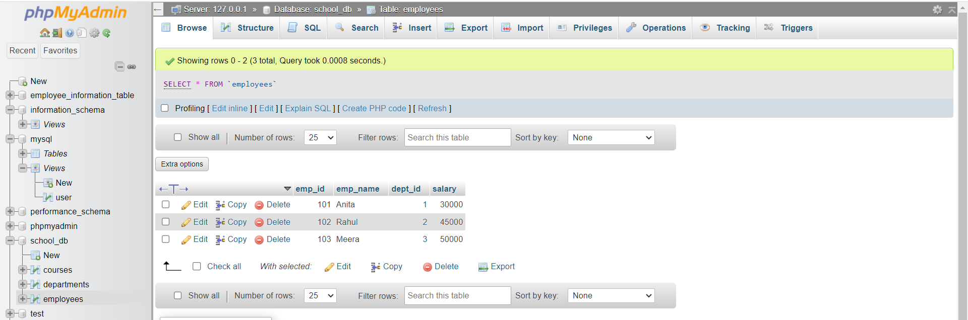

Query: Find Average Salary per Department (Using AVG)
SELECT dept_id, AVG(salary) AS average_salary
FROM employees
GROUP BY dept_id;
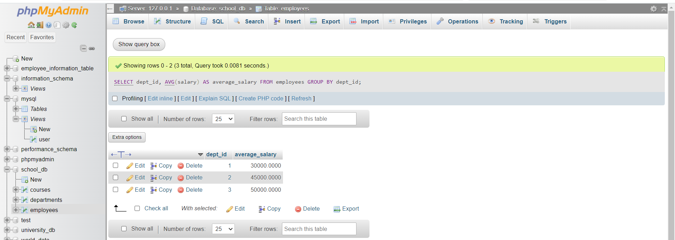

13. SQL Stored Procedure
Lab 1: Write a stored procedure to retrieve all employees from the employees table based
on department.
Answer:
Query: Stored Procedure to Retrieve Employees by Department
- Stored Procedure
DELIMITER $$
CREATE PROCEDURE GetEmployeesByDepartment(IN dept INT)
BEGIN
SELECT emp_id, emp_name, dept_id
FROM employees
WHERE dept_id = dept;
END $$
DELIMITER ;
- How to Execute the Procedure
CALL GetEmployeesByDepartment(2);
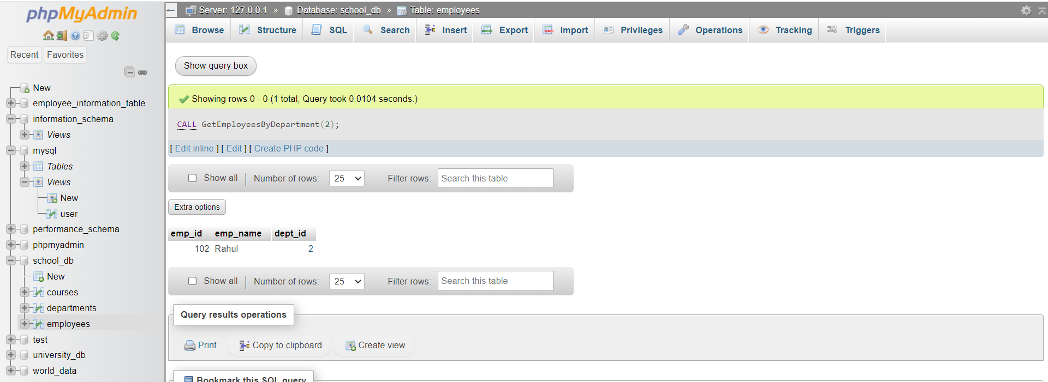
- This procedure returns employees who work in a specific department.

Lab 2: Write a stored procedure that accepts course_id as input and returns the course
details.
Answer:
Query: Stored Procedure to Retrieve Course Details by course_id
- Stored Procedure
DELIMITER $$
CREATE PROCEDURE GetCourseDetails(IN c_id INT)
BEGIN
SELECT course_id, course_name, course_duration
FROM courses
WHERE course_id = c_id;
END $$
DELIMITER ;
- How to Execute the Procedure
CALL GetCourseDetails(101);
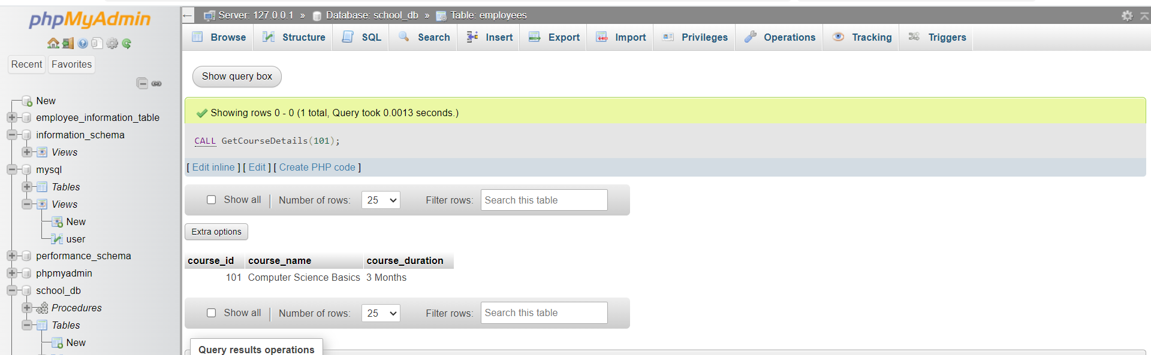
- This procedure returns only the details of the course whose ID you pass.

14. SQL View
Lab 1: Create a view to show all employees along with their department names.
Answer:
Query: Create a View to Show Employees with Department Names
- Step 1: Create a VIEW using JOIN
CREATE VIEW employee_department_view AS
SELECT e.emp_id, e.emp_name, e.salary, d.dept_name
FROM employees e
INNER JOIN departments d
ON e.dept_id = d.dept_id;
- Step 2: To see the view
SELECT * FROM employee_department_view;
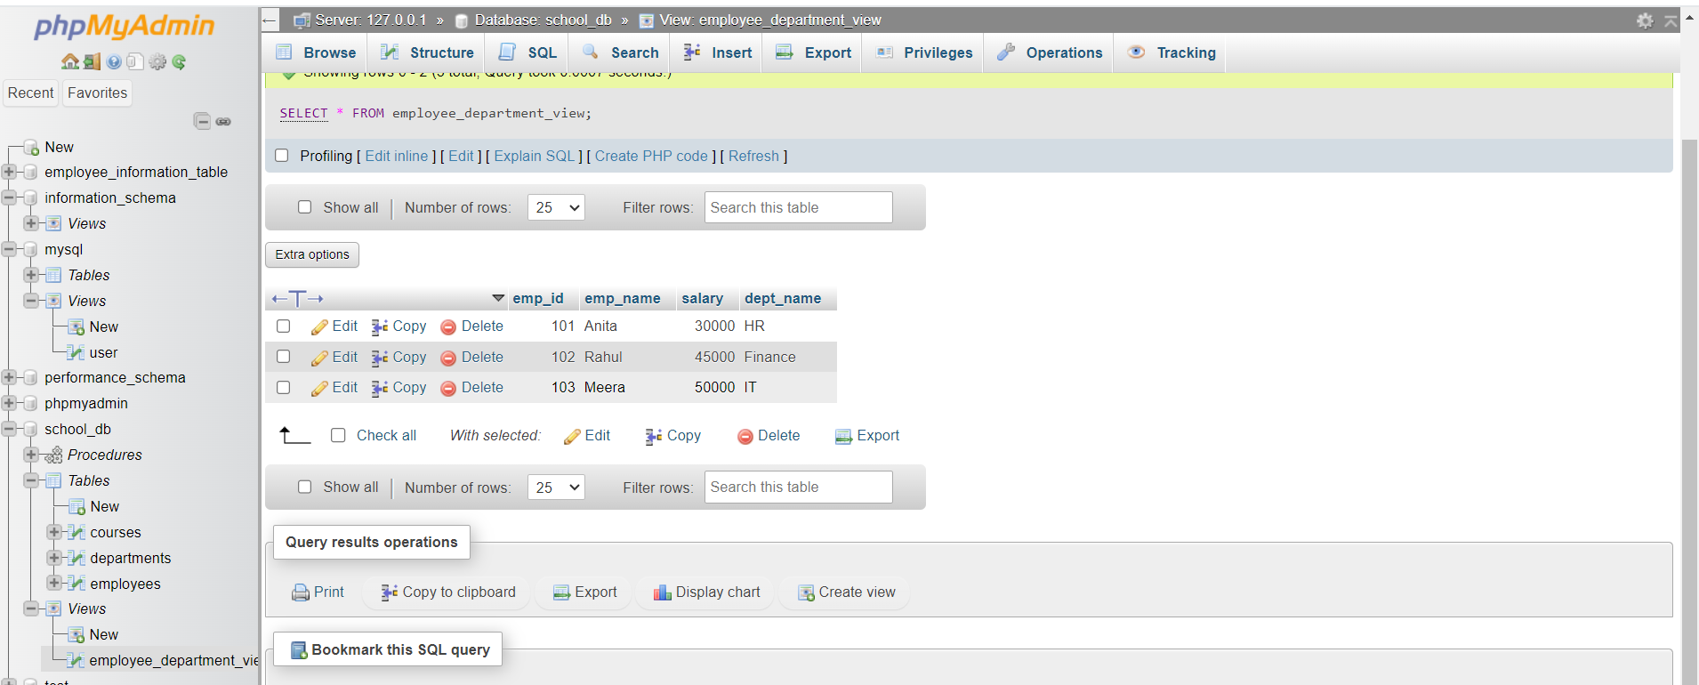

Lab 2: Modify the view to exclude employees whose salaries are below $50,000.
Answer:
Query: Modify the View to Exclude Employees with Salary < 50,000
- Use OR REPLACE to update the view
CREATE OR REPLACE VIEW employee_department_view AS
SELECT e.emp_id, e.emp_name, e.salary, d.dept_name
FROM employees e
INNER JOIN departments d
ON e.dept_id = d.dept_id WHERE e.salary >= 50000;
- To check updated view
SELECT * FROM employee_department_view;

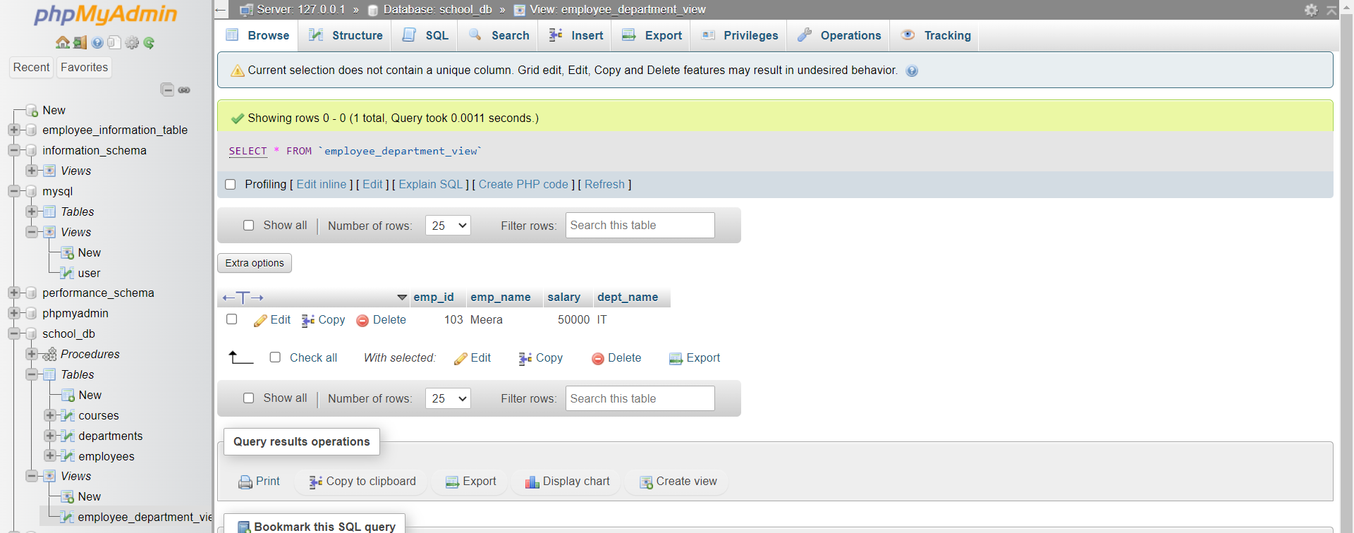

15. SQL Triggers
Lab 1: Create a trigger to automatically log changes to the employees table when a new
employee is added.
Answer:
Query: Trigger to Log New Employee Insertions
- Step 1: Create a log table
You need a table to store log records.
CREATE TABLE employee_log (
log_id INT AUTO_INCREMENT PRIMARY KEY,
emp_id INT,
emp_name VARCHAR(50),
action_performed VARCHAR(20),
log_time TIMESTAMP DEFAULT CURRENT_TIMESTAMP
);
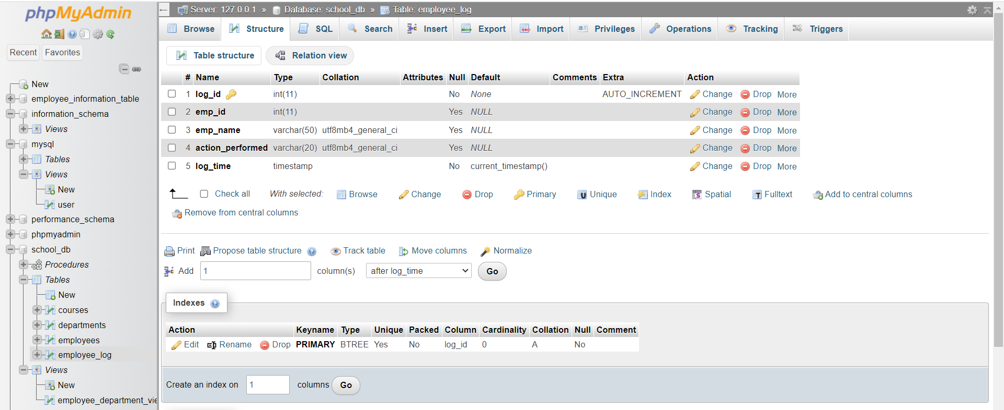
- Step 2: Create the trigger
This trigger will run AFTER a new employee is inserted.
DELIMITER $$
CREATE TRIGGER log_new_employee
AFTER INSERT ON employees
FOR EACH ROW
BEGIN
INSERT INTO employee_log (emp_id, emp_name, action_performed)
VALUES (NEW.emp_id, NEW.emp_name, 'INSERT');
END $$
DELIMITER ;
- Sample Output
(After inserting a new employee)
INSERT INTO employees (emp_id, emp_name, dept_id, salary)
VALUES (107, 'Suresh', 2, 48000);
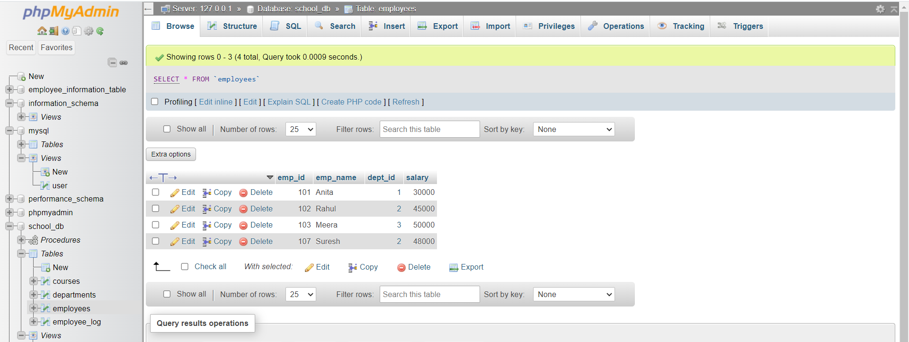
- Running:
SELECT * FROM employee_log;

Lab 2: Create a trigger to update the last_modified timestamp whenever an employee
record is updated.
Answer:
Query: Trigger to Automatically Update last_modified Timestamp
- Step 1: Add a column to employees table
ALTER TABLE employees
ADD last_modified TIMESTAMP DEFAULT CURRENT_TIMESTAMP;
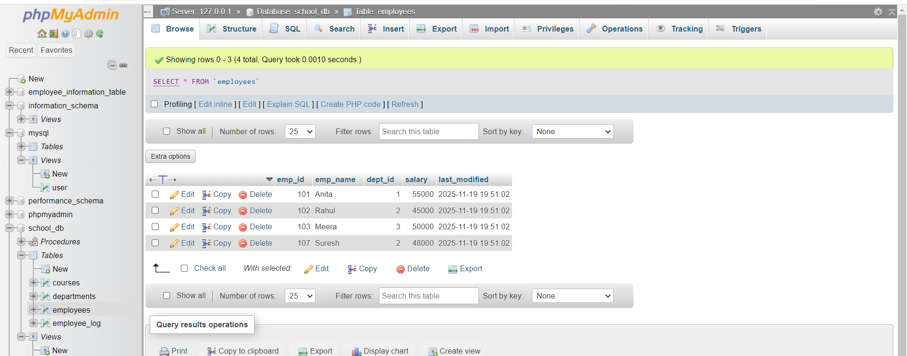

- Step 2: Create the UPDATE trigger
This trigger updates the timestamp whenever an employee record changes.
DELIMITER $$
CREATE TRIGGER update_last_modified
BEFORE UPDATE ON employees
FOR EACH ROW
BEGIN
SET NEW.last_modified = CURRENT_TIMESTAMP;
END $$
DELIMITER ;
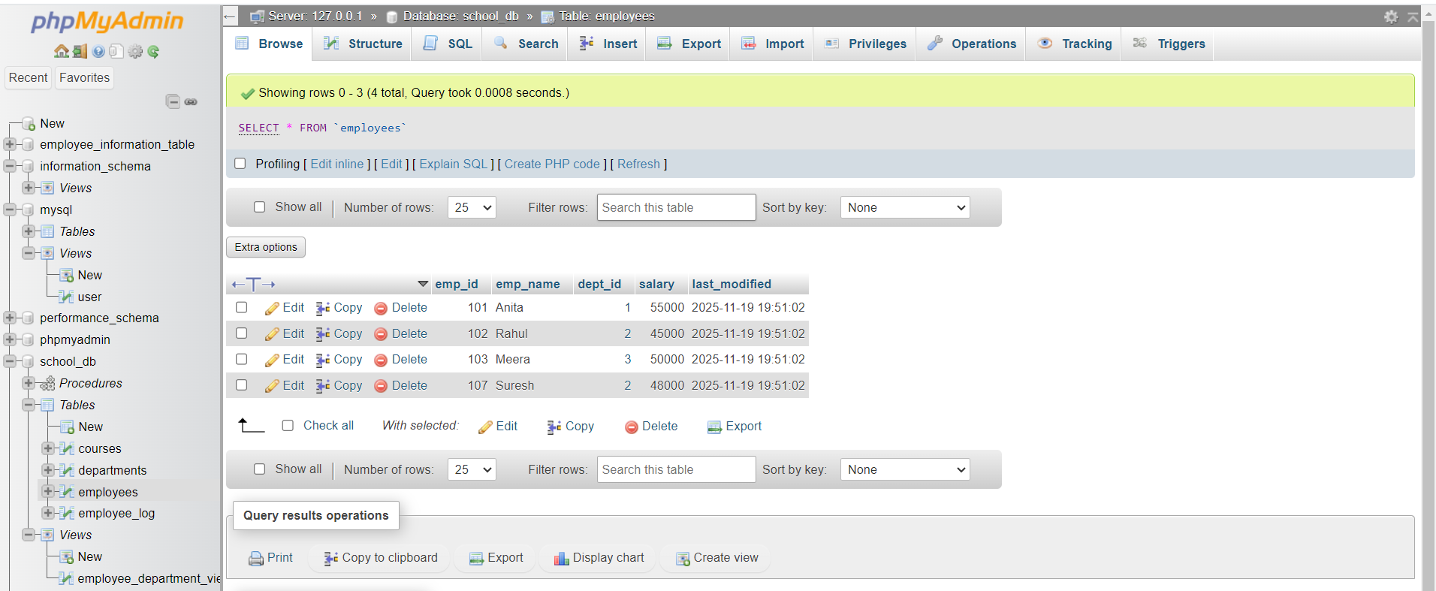

- Example Update
UPDATE employees
SET salary = 55000
WHERE emp_id = 101;
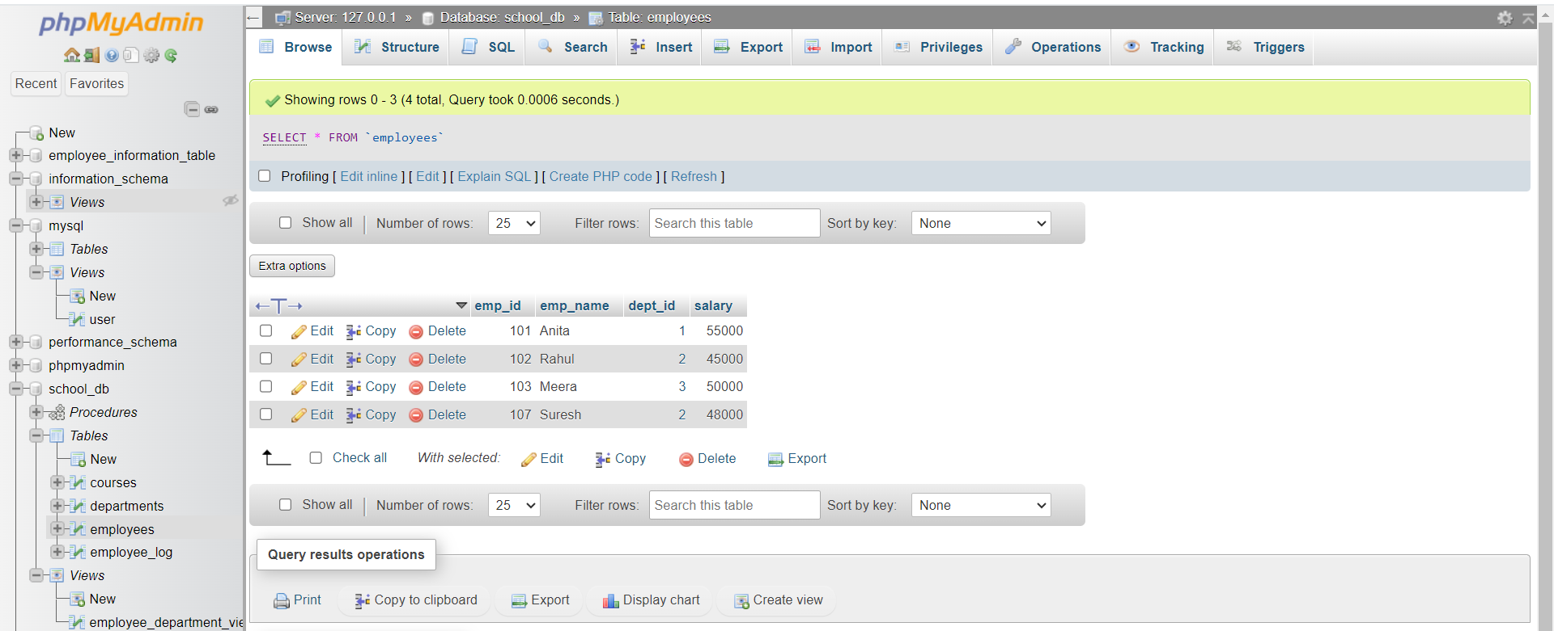

- Output (View the updated timestamp)
SELECT emp_id, emp_name, salary, last_modified FROM employees;

- Automatically updated — no need to manually set last_modified.

16. Introduction to PL/SQL
Lab 1: Write a PL/SQL block to print the total number of employees from the employees
table.
Answer:
Query: Print total number of employees
SELECT COUNT(*) AS total_employees FROM employees;
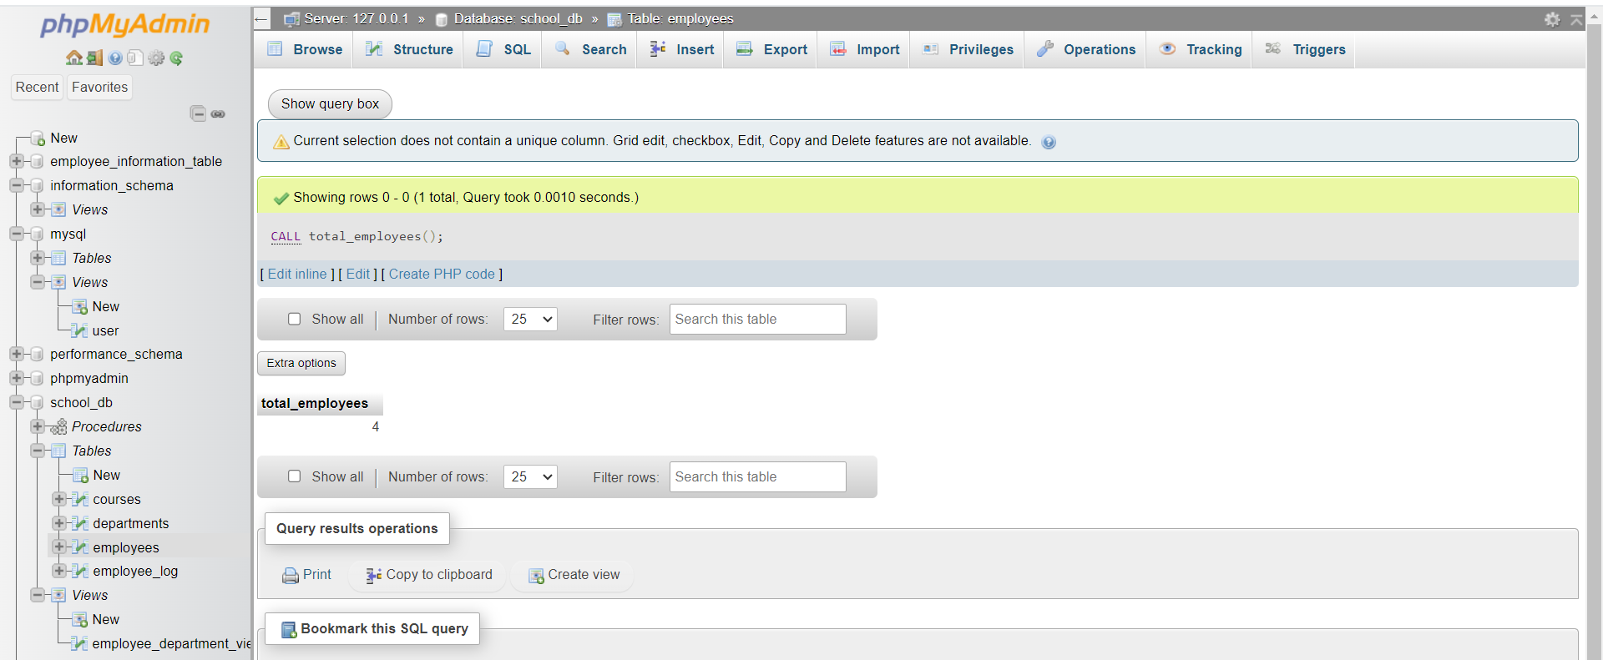

Lab 2: Create a PL/SQL block that calculates the total salary from an orders table.
Answer:
Query: Calculate Total Salary
SELECT SUM(salary) AS total_salary FROM employees;
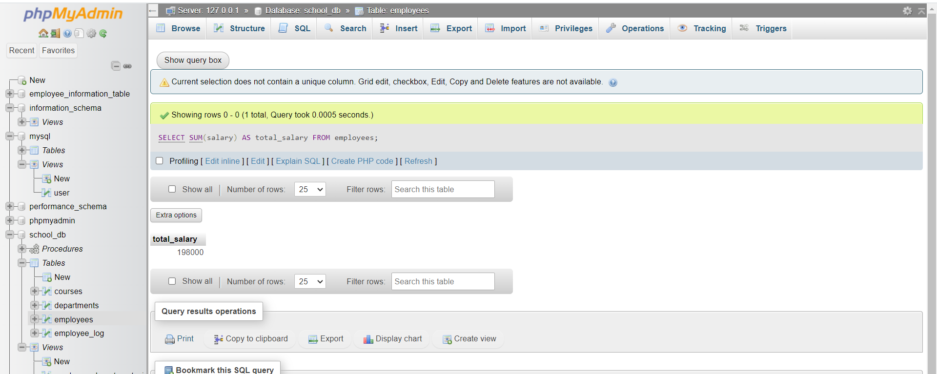

17. PL/SQL Control Structures
Lab 1: Write a PL/SQL block using an IF-THEN condition to check the department of an
employee.
Answer:
Query 1: Stored Procedure
DELIMITER $$

CREATE PROCEDURE check_department(IN p_emp_id INT)
BEGIN
DECLARE v_dept INT;

SELECT dept_id INTO v_dept
FROM employees
WHERE emp_id = p_emp_id;

IF v_dept = 2 THEN
SELECT 'Employee belongs to Department 2' AS message;
ELSE
SELECT 'Employee does NOT belong to Department 2' AS message;
END IF;
END $$

DELIMITER ;
Query 2: Call the Procedure
CALL check_department(102);
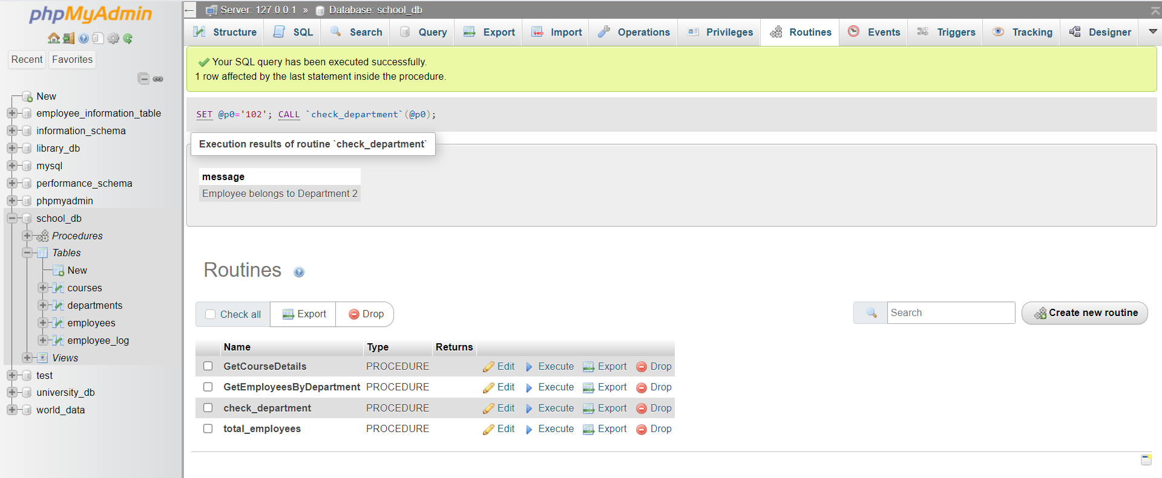

Lab 2: Use a FOR LOOP to iterate through employee records and display their names.
Answer:
Query 1: Stored Procedure with FOR-LIKE LOOP (MySQL uses WHILE)
DELIMITER $$

CREATE PROCEDURE show_employee_names()
BEGIN
DECLARE done INT DEFAULT 0;
DECLARE v_name VARCHAR(50);

DECLARE emp_cursor CURSOR FOR
SELECT emp_name FROM employees;

DECLARE CONTINUE HANDLER FOR NOT FOUND SET done = 1;

OPEN emp_cursor;

read_loop: LOOP
FETCH emp_cursor INTO v_name;
IF done = 1 THEN
LEAVE read_loop;
END IF;

SELECT v_name AS employee_name;
END LOOP;

CLOSE emp_cursor;
END $$

DELIMITER ;

Query 2: Call the procedure
CALL show_employee_names();
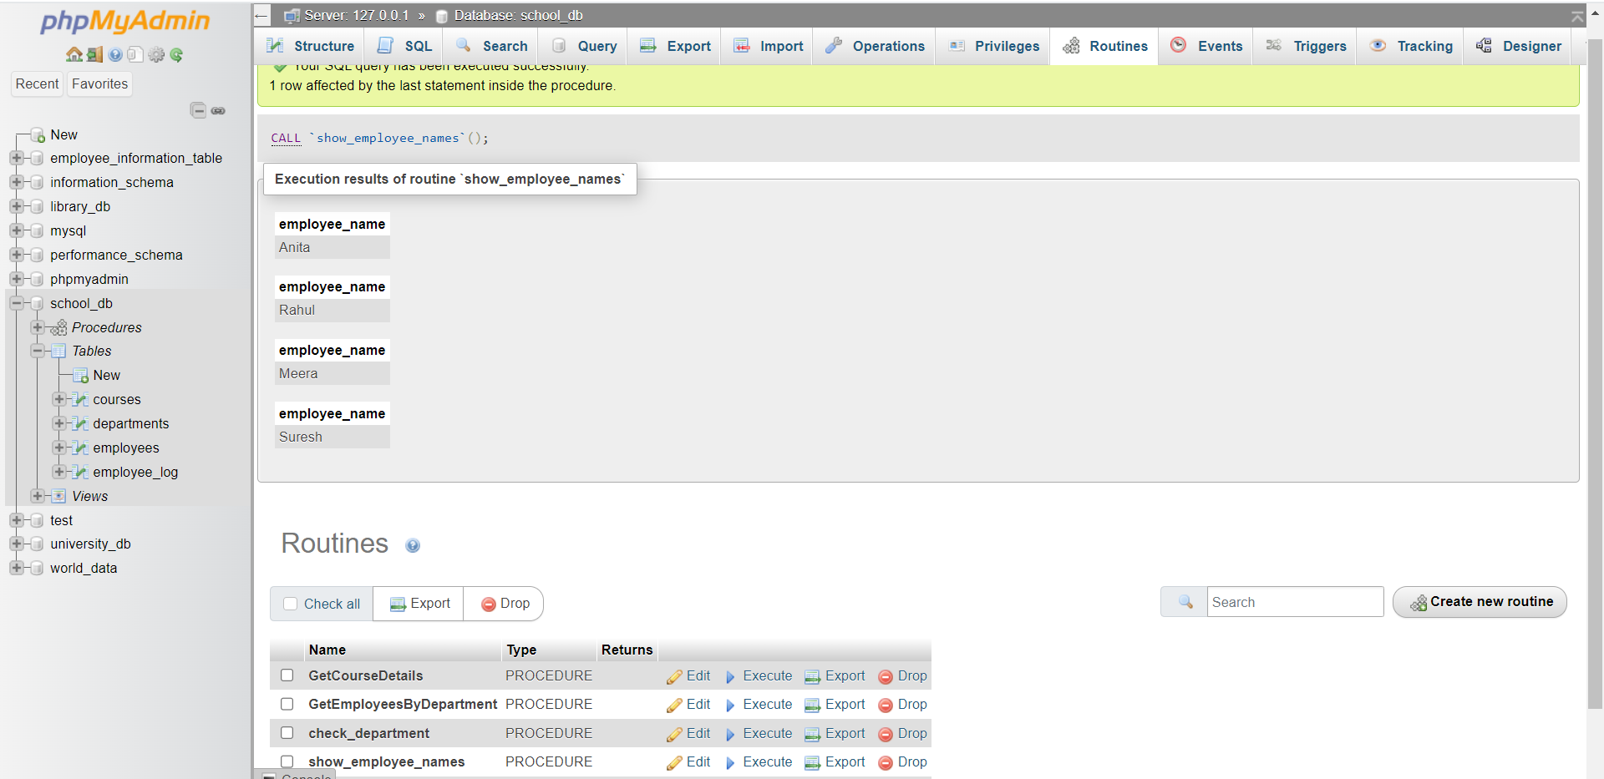

18. SQL Cursors
Lab 1: Write a PL/SQL block using an explicit cursor to retrieve and display employee details.
Answer:
Query 1: Stored Procedure
DELIMITER $$

CREATE PROCEDURE show_employee_details()
BEGIN
DECLARE done INT DEFAULT 0;
DECLARE v_id INT;
DECLARE v_name VARCHAR(50);
DECLARE v_dept INT;
DECLARE v_salary INT;

DECLARE emp_cursor CURSOR FOR
SELECT emp_id, emp_name, dept_id, salary FROM employees;

DECLARE CONTINUE HANDLER FOR NOT FOUND SET done = 1;

OPEN emp_cursor;

read_loop: LOOP
FETCH emp_cursor INTO v_id, v_name, v_dept, v_salary;
IF done = 1 THEN
LEAVE read_loop;
END IF;

SELECT CONCAT(
'ID: ', v_id,
', Name: ', v_name,
', Dept: ', v_dept,
', Salary: ', v_salary
) AS Employee_Details;
END LOOP;

CLOSE emp_cursor;
END$$

DELIMITER ;

Query 2: Run the procedure
CALL show_employee_details();
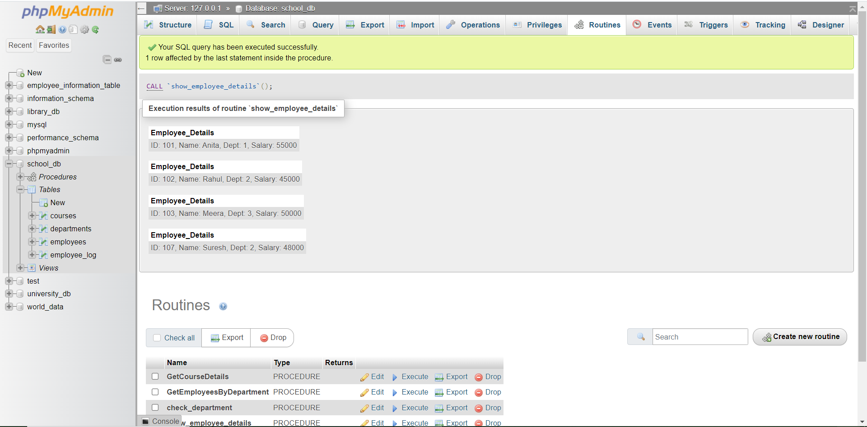

Lab 2: Create a cursor to retrieve all courses and display them one by one.
Answer:
Query 1: Stored Procedure
DELIMITER $$

CREATE PROCEDURE show_courses()
BEGIN
DECLARE done INT DEFAULT 0;
DECLARE v_id INT;
DECLARE v_name VARCHAR(100);
DECLARE v_duration VARCHAR(50);

DECLARE course_cursor CURSOR FOR
SELECT course_id, course_name, course_duration FROM courses;

DECLARE CONTINUE HANDLER FOR NOT FOUND SET done = 1;

OPEN course_cursor;

course_loop: LOOP
FETCH course_cursor INTO v_id, v_name, v_duration;
IF done = 1 THEN
LEAVE course_loop;
END IF;

SELECT CONCAT(
'Course ID: ', v_id,
', Name: ', v_name,
', Duration: ', v_duration
) AS Course_Details;
END LOOP;

CLOSE course_cursor;
END$$

DELIMITER ;

Query 2: Run the procedure
CALL show_courses();
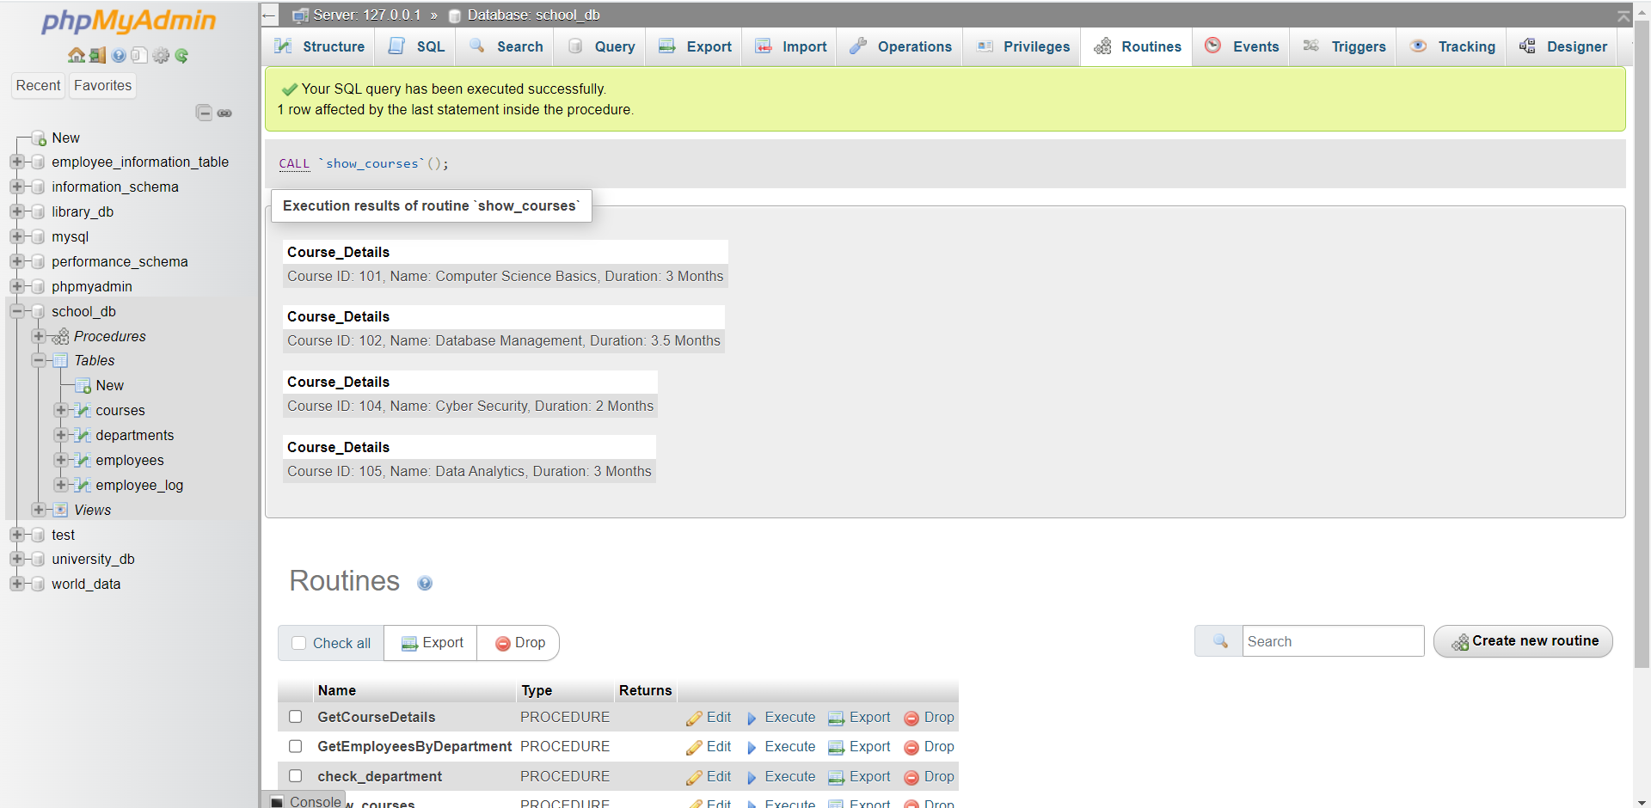

19. Rollback and Commit Savepoint
Lab 1: Perform a transaction where you create a savepoint, insert records, then rollback to
the savepoint.
Answer:
Query: Create Savepoint → Insert Records → Rollback to Savepoint
-- Start the transaction
START TRANSACTION;

-- Insert 1st record
INSERT INTO employees (emp_id, emp_name, dept_id, salary)
VALUES (110, 'TestUser1', 1, 30000);

-- Create savepoint
SAVEPOINT sp1;

-- Insert 2nd record
INSERT INTO employees (emp_id, emp_name, dept_id, salary)
VALUES (111, 'TestUser2', 2, 40000);

-- Rollback to savepoint (means the 2nd insert will be removed)
ROLLBACK TO sp1;

-- Commit remaining changes
COMMIT;
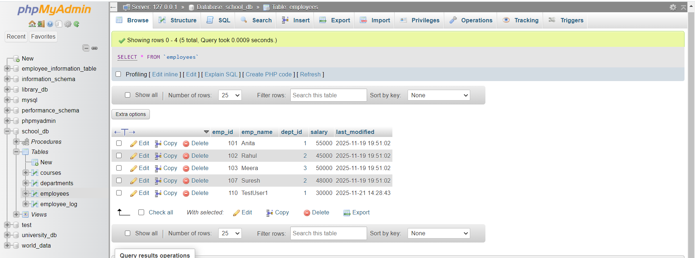
Lab 2: Commit part of a transaction after using a savepoint and then rollback the remaining changes.
Answer:
Query: Commit part of a transaction → Rollback remaining changes
-- Start transaction
START TRANSACTION;

-- Insert two new employees
INSERT INTO employees (emp_id, emp_name, dept_id, salary)
VALUES (120, 'PartialUser1', 1, 35000);

INSERT INTO employees (emp_id, emp_name, dept_id, salary)
VALUES (121, 'PartialUser2', 2, 36000);

-- Create savepoint
SAVEPOINT sp2;

-- Insert another record
INSERT INTO employees (emp_id, emp_name, dept_id, salary)
VALUES (122, 'RollbackUser', 3, 37000);

-- Commit changes BEFORE savepoint (120, 121)
RELEASE SAVEPOINT sp2;
COMMIT;

-- Now rollback remaining uncommitted changes
ROLLBACK;
